Audio Signals are often added up by noise from audio equipments. Denoising is removing the noise while retaining the original signal to the maximum extent.

In this experiment out aim is to de-noise a given noisy signal. Two types of noises were added to the speech signal:-

1. DC hums.
2. Electromagnetic interference.

Constant humming sound that gets added to the signal of interest makes a DC hum. The DC hum present in the given signal has a frequency component of 50 Hz and its harmonics.

The actual noise frequencies present in the signal are clear from the frequency domain representation of the signal. There are peaks in the power spectrum of the signal at 50 Hz and at various harmonics of 50 Hz.

**The circuit used to remove this DC hums is Twin T circuit.**

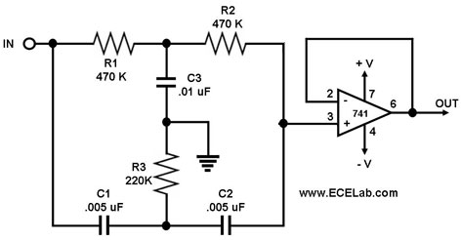

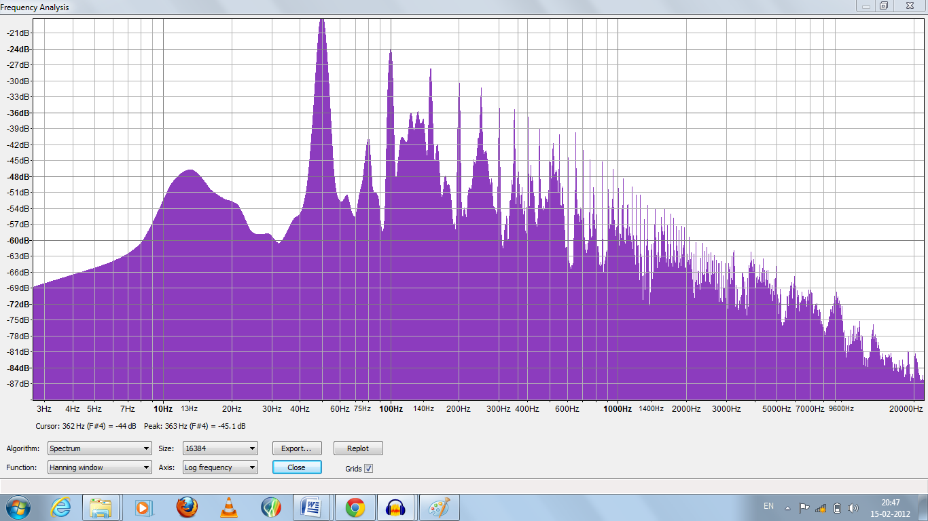

**Frequency spectrum of noisy signal**

**Filtered noisy signal**

The original signal after passing through a notch filter filters out the harmonics of the noisy signal. The output of the notch filter reduces the amplitude of the signal at 50 Hz and at its harmonics. The time domain is as shown in the figure. The filtering is not clear in the time domain.

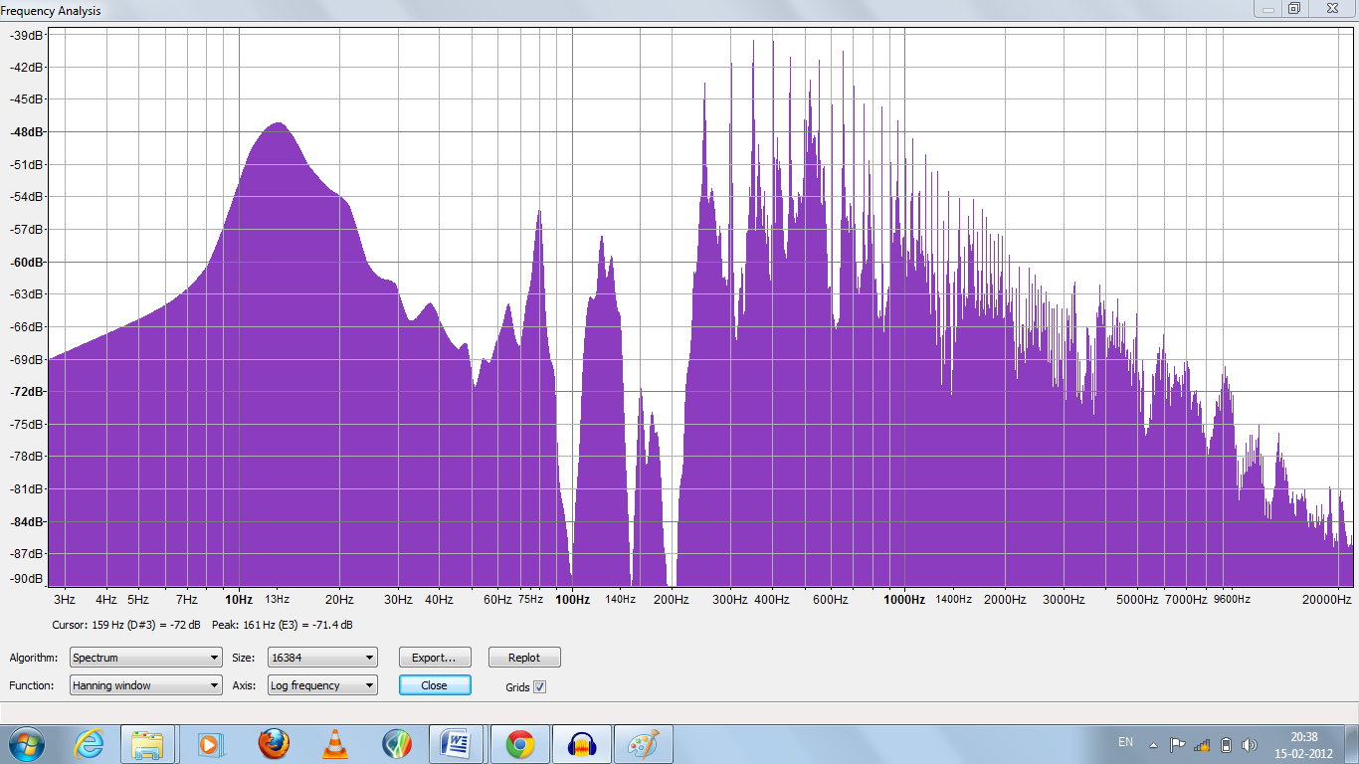**Frequency domain filtered signal**

Note :

1. The output signal is not completely de-noised as there are some DC hum components present this is because of the higher harmonics still present in the signal.

2. It is not possible to completely remove the noise as the amplitude of the noise is much greater than the amplitude of original signal.